Sam and You: Comparing the past and the Present

Learn about daily life for Sam Cockayne and how it is different from our lives today.

Suggested Grade Levels: 4-6
Designers: Keysha Allison and Karina Vazquez

Materials
- Copy of Sam’s essay
- Blank writing page for each student
- PowerPoint slide show (if unable to visit the Cockayne house in person)
Procedures
- Before arrival, have the students write down the names of three people who have taught them something in their life. They will need to set aside the list until the end of the lesson.
- The instructor will then provide background information of Sam as a child and his family. Ex. Photographs and the essay Sam wrote about what his father taught him. (Have the students read the essay out loud)
- Ask the students “What do you think Sam would have ____” (ex. Played with, ate, wore to school, wore to work, done for fun, done for chores, etc.)
- Show and compare some of the artifacts from the house to today.
- When returning back to the class, have students take out their list and a blank piece of lined paper.
- Explain that the students will then each write their own essay about what they have been taught by one of the people on their list.
Closure
- Ask for a few volunteers to read their essays out loud to the class and compare it to Sam’s essay.

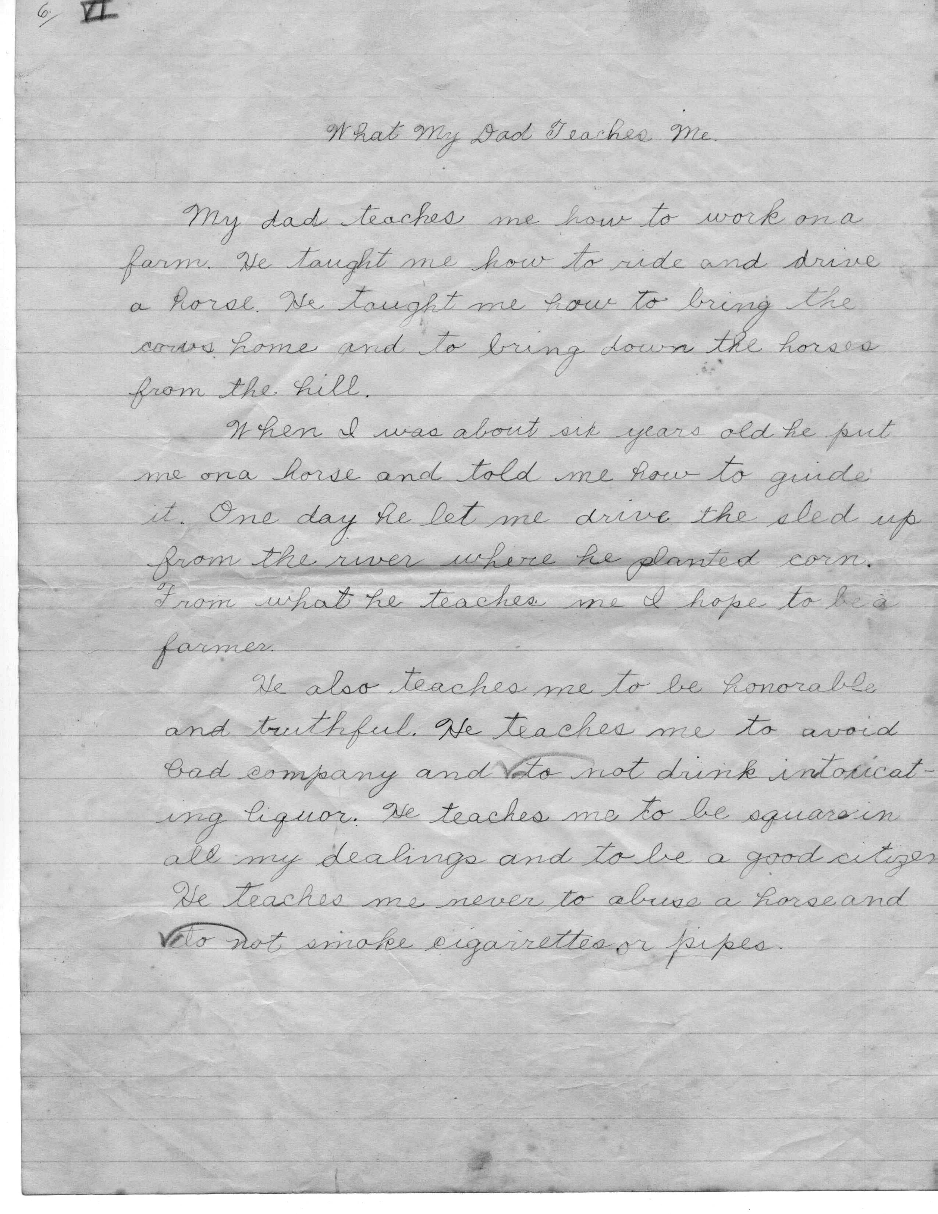

What My Dad Teaches Me
My dad teaches me how to work on a farm. He taught me how to ride and drive a horse. He taught me how to bring the cows home and to bring down the horses from the hill.
When I was about six years old he put me on a horse and told me how to guide it. One day he let me drive the sled up from the river where he planted corn. From what he teaches me I hope to be a farmer.
He also teaches me how to be honorable and truthful. He teaches me to avoid bad company and to not drink intoxicating liquor. He teaches me to be square in all my dealings and to be a good citizen. He teaches me never to abuse a horse and to not smoke cigarettes or pipes.

